My favourite foods
Hi, I’m Donny. I’m 10 years old. I’m form China. I’m Chinese boy. I study in Dongfengdonglu Primary school. I’m in Class 5 grade 4. My favourite sport is swim, I eat watermelon after swimming. Watermelon has vitamins C. It can help me grow up, and it is delicious.
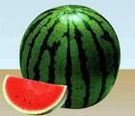
I like hamburger too. It has meat and vegetable. They can help me grow up too. And it is great.
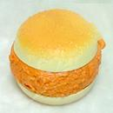
I like coke too. It has water and artefact. Although coke absence nutrition. But coke is really good.
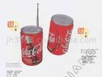

严泓罡 四（5） 21号

