Hello! My name is Hanna. My bedroom is how beautiful! I like my bedroom.
There is a pink bed, an orange bookshelf, a white desk, three pink sofas, break piano in my bedroom. There is a computer on the desk.
There are four white walls. There are tow big windows on the wall. They make the room bright.
This is my bedroom. I study and sleep here everyday.

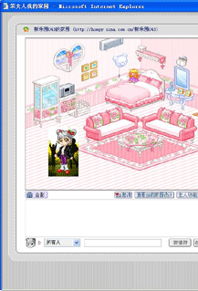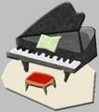

DongFengDong Lu Primary School
Class Five Grade Three
No.40容蓉(Hanna)

