My bedroom`
Hello, everyone.
My name’s David. This is my bedroom.
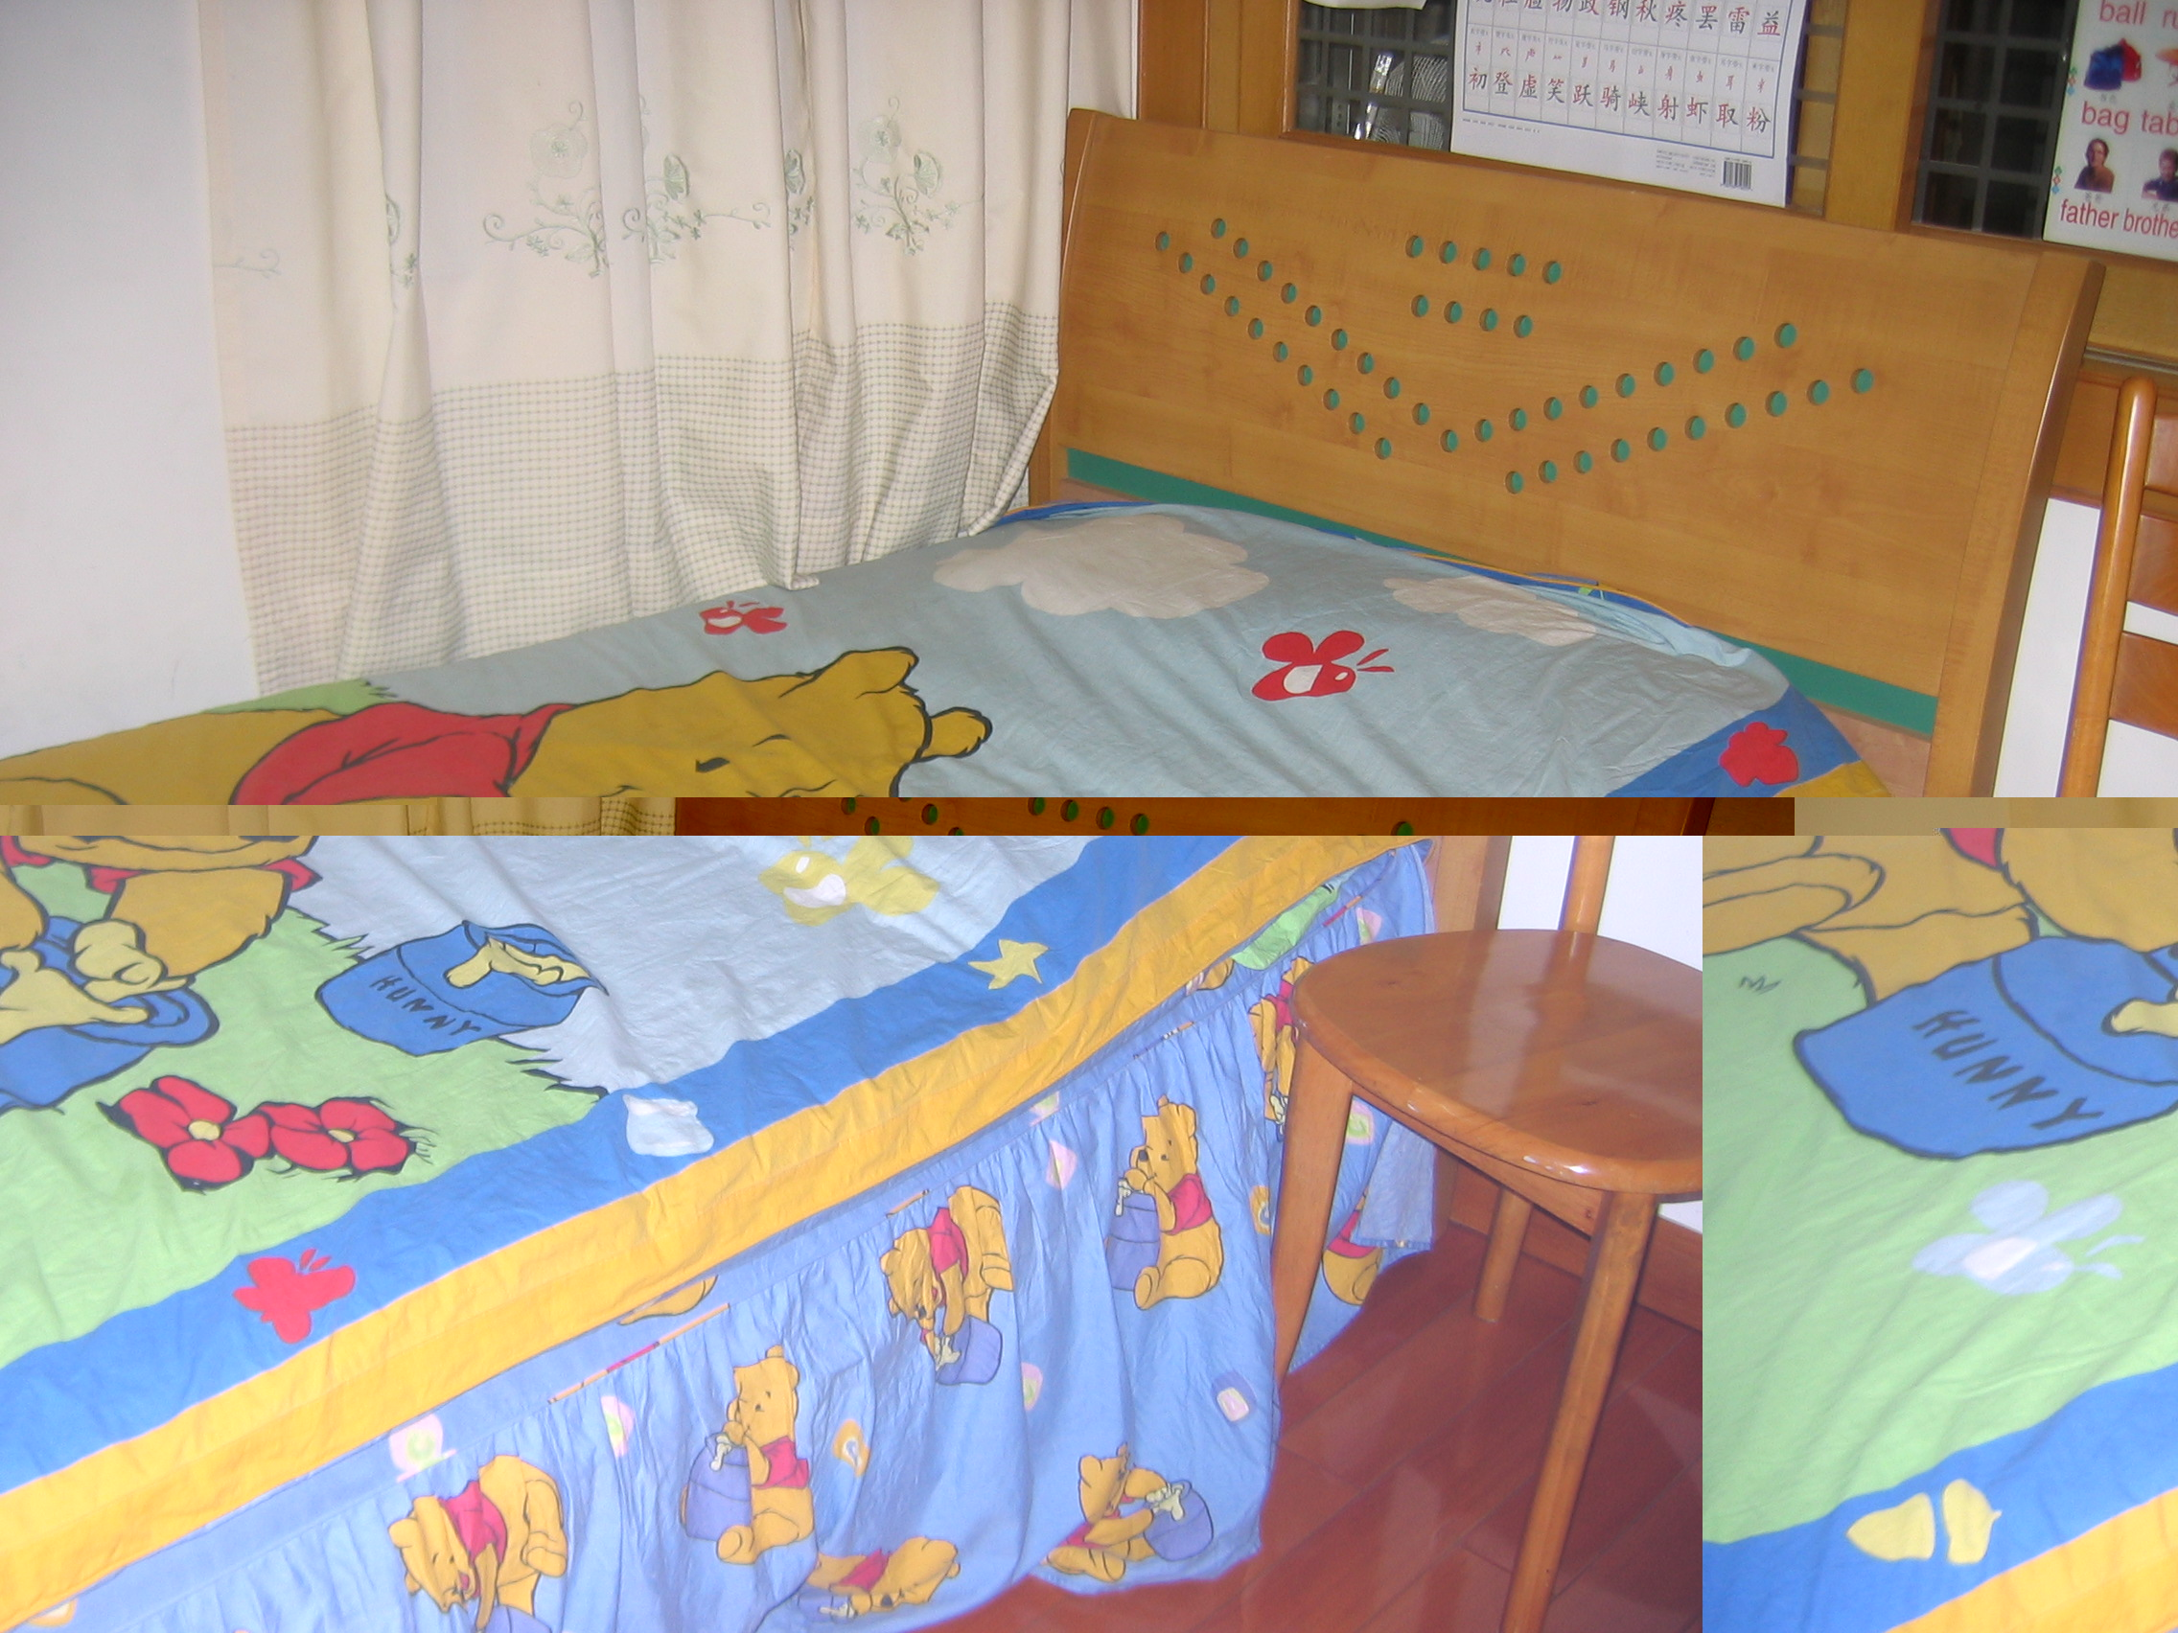
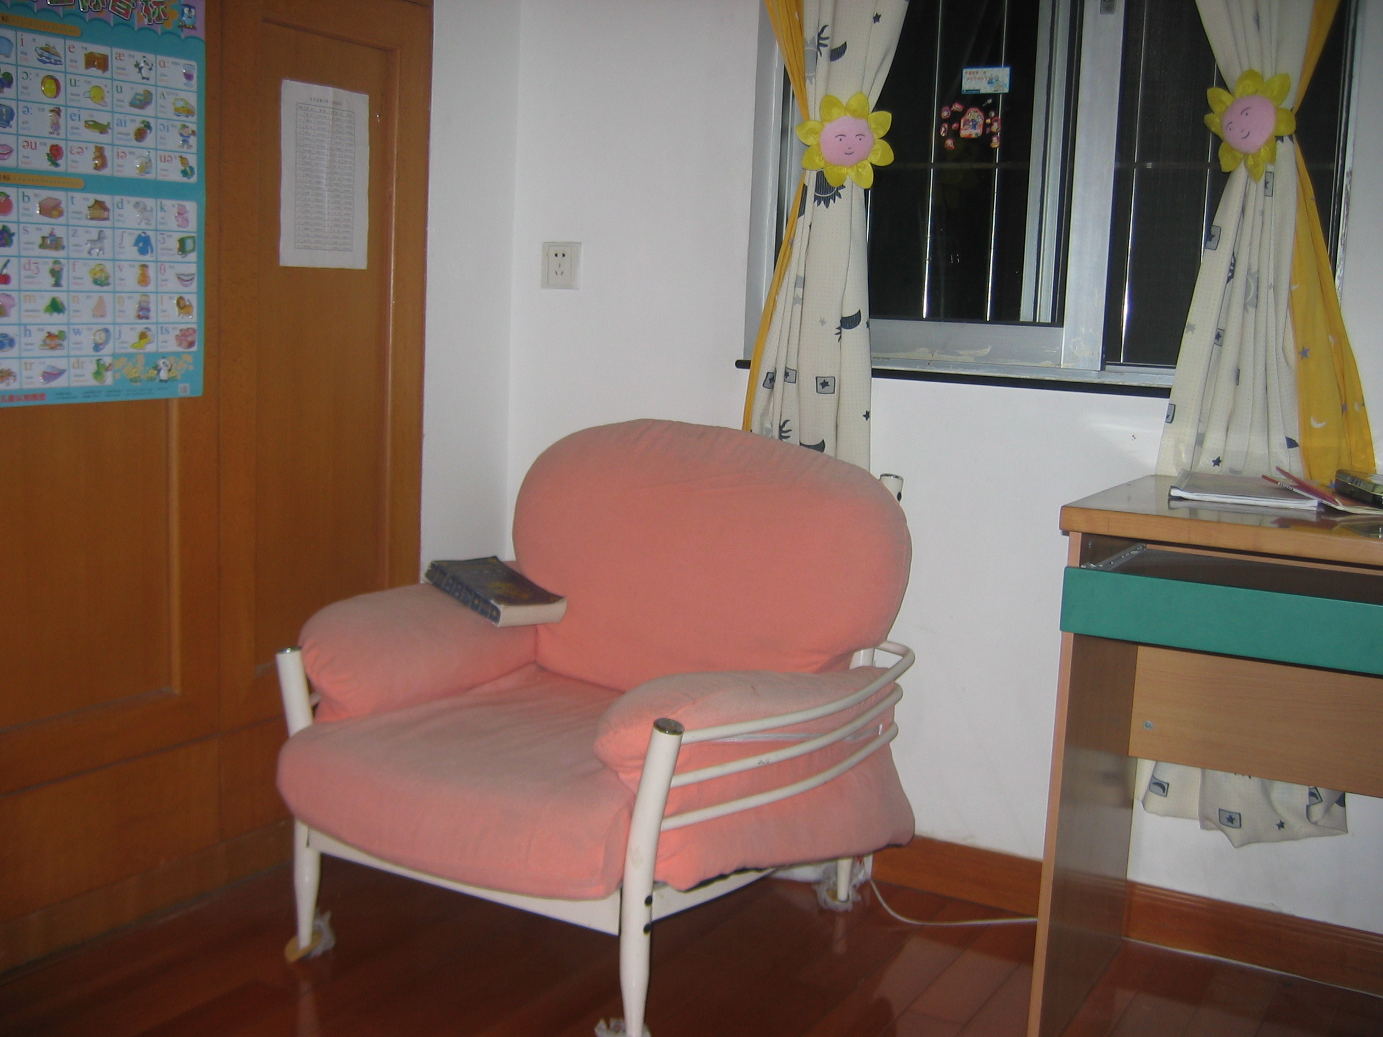
Look! There are two windows in the wall. They make the room bright. There is a pink sofa near the window, I often read in it. There is a bookcase near the sofa. My favorite book is in the bookcase, I like reading, and I read almost everyday. In front of the window, there is a desk. I do my homework on the desk. There is a very good computer on the desk. I’ll go on internet to search some useful information. I like English very much. I want to read a lot of English novels.
My bed is blue and red. It is comfortable, so I sleep in my bed very well. I often jump on the bed. Yesterday the leg of my bed was broken.

Dongfengdong Lu Primary School
Class 5 Grade 3
NO. 10金石鸣(David)

