My bedroom


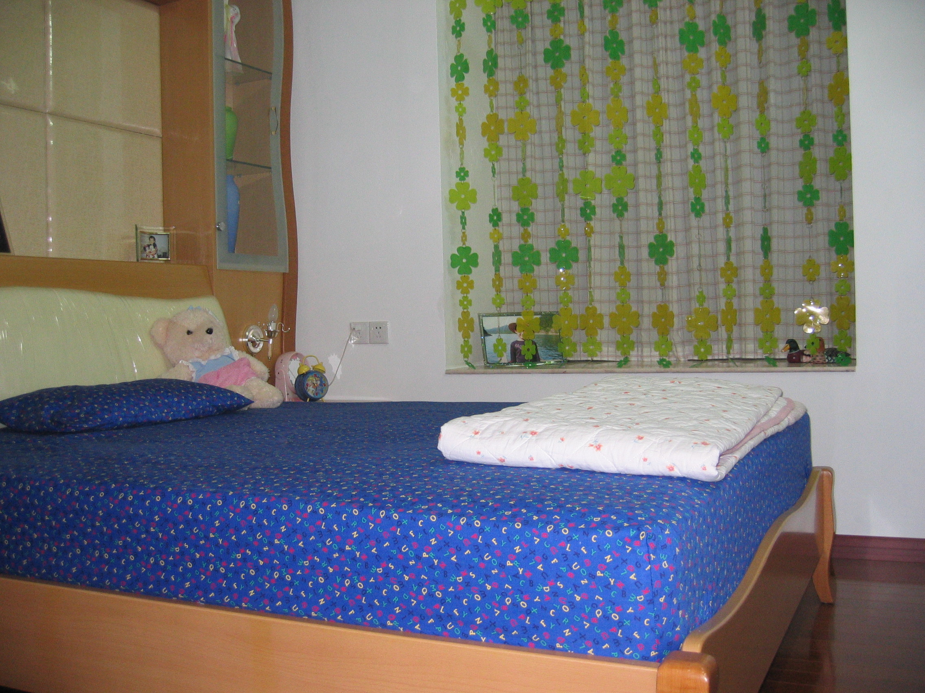


Hello, I’m Sunny. How are you? Look at this picture. I’m glad to talk about my bedroom. The floor is brown. On the floor, I can see a brown and blue bed. On the bed, I can see a red and white quilt, in the quilt, I can see pink flower. The bed is next to the window. Look! On the window ,there are many yellow and green flowers, they are very beautiful! So I like my bedroom very much. What do you think of? Do you like my bedroom? What about yours?
Class Five Grade Three Sunny No.29

