科教2011课标版三年级起点五年级下册
Unit 11 Can you tell me the way ? 教学设计
三元坊小学 黄琳
一、教材：
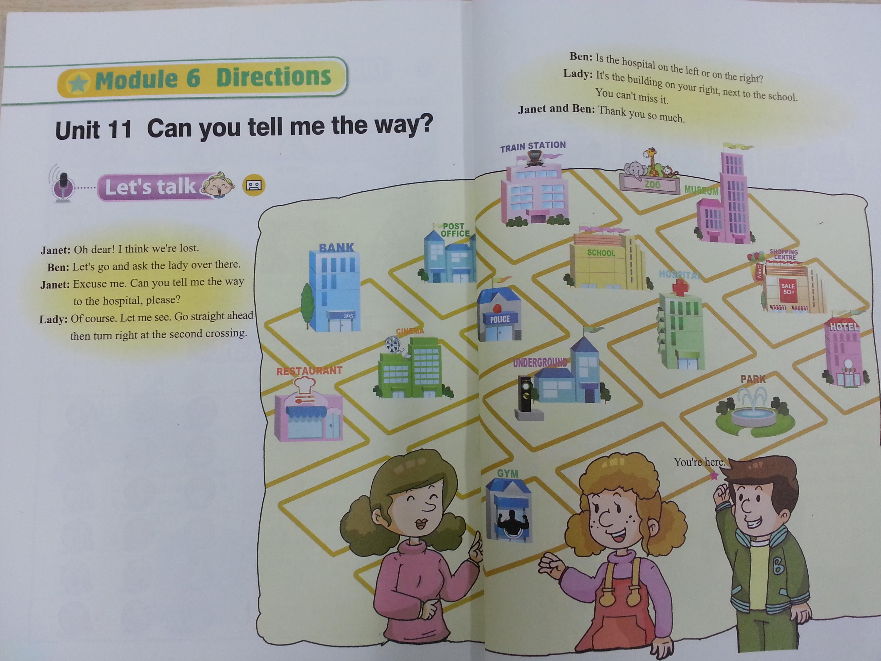
二、教学内容：
Unit 11 Can you tell me the way ?的对话
- 教学目标：
- 语言知识目标：
①词汇： way , lose / lost ,hospital , straight , ahead , right, left, miss , Excuse me.
②句型：
问路：Excuse me . Can you tell me the way to (the hospital ),please?
指路：Yes ,turn left /right out of the ..
Go straight ahead , turn right at the second crossing.
It’s on your left /right.It’s the third building on your right, next to （the school ）.
③日常用语：
Oh dear! Let me see. You can’t miss it.
- 语言技能目标：
① 能用句型Excuse me . Can you tell me the way to (the hospital ),please?进行问路，用Yes ,turn left /right out of the ..Go straight ahead , turn right at the second crossing. It’s on your left /right.It’s the third building on your right, next to （the school ）.进行指路。
②能理解课文，并流利地朗读课文
通过反复的口头练习，使学生能熟练的使用问路的交际用语，并能根据具体情况灵活运用。能用所学的语言知识进行问路和指路。
- 拓展目标：
①通过师生说、小组说、两两说、自主说等形式更好地巩固问路和指路的句型。
②制作一份地图，并让学生模拟真实情景进行对话、小练笔已达到巩固所学知识。
- 情感态度目标：
通过多媒体课件进行教学增强学生学习英语的兴趣与热情，同时培养学生的合作互助精神，培养学生助人为乐的精神。
- 教学重点：
- 让学生能“四会”掌握本课的语言知识
- 课文的学习。
- 教学难点：
1.“四会”单词的记忆
2. It’s the third building on your right, next to the school. 的句型理解
六、学情分析：
这个班的学生是实验班的学生，他们热情好学，积极性很高。两极分化比较严重，经过几年的学习和积累，他们学习及运用语言的能力都有了很大的发展。对于课文的朗读及单词的认读在预习的时候都基本可以解决，所以在教学过程我对他们一般都有所拔高，更注重语言的灵活运用。
七、资源准备：
1.跨越式课题组提供的英语资源
2.PPT课件
3.思维导图的应用
4.改编的英语故事
八、教学策略：
1.借助实物、多媒体工具等呈现新知识，创设情境让学生理解和操练语言知识点。
2.采用情景教学，帮助学生理解和记忆课文对话，让学生在自己熟悉的情境中感知，在不知不觉中习得语言，最终能用于交际中。再考虑到英语教学的特点，因此在网络课中加入传统课的一些教学方法，如唱歌，小组比赛，竞猜等，让学生在“听、说、读、写”各方面得到训练，同时也活跃课堂气氛。

九、教学过程：
I． Warming up ＆ Revision
1.Let’s chant
Right , right , right ,on the right .
Left , left ,left , on the left .
It’s on the right.
It’s on the left .
Is it on the right or on the left ?
Is the zoo on the right or on the left ?
It’s on the right .
2. 看PPT ，复习 What’s your favourite place ? My favourite place is …
3. Guess game: What place is it?
复习：①shopping centre ② cinema ③ museum ④ restaurant
⑤ hotel
II . Presentation＆ Practice
1. 介绍本节课的教学目标
2. Did you know ?
①turn left 并学习left
②turn right 并学习right
③go straight ahead 并学习straight 、ahead
④Turn left at the first crossing.
⑤Turn right at the second crossing.
⑥go straight ahead and take the third right
⑦go straight ahead and take the second left
3.Practice with your partner ,用以上句型，生生之间发出命令，互相做动作。
4.老师扮游客，出来与学生表演对话。并导出新课
T: I’m the tourist . I’m lost . Can you help me ?
- 新课学习：
①学习：Excuse me . Can you tell me the way to the hosipital , please ? Go straight ahead . Then turn right at the second crossing . It’ s on your right ,next to the school .
②看PPT进行练习。
③ Practice with your partner，use the map of PPT（ 同位练习并表演）
- Learn the dialogue:
①看课文DVD
②跟读
③分角色读
④看课文PPT，读出所缺的单词
⑤根据课文判断T或者F：
（ ）1. Janet wants to go to the restaurant.
( ) 2. The hospital is in front of the school.
( )3. Go straight ahead then turn right at the second crossing ,next to the school . We can find the hospital.
III . Conclusion＆ Homework
- 看视频，回答问题：
How can the man get to Nanjing Road ?
2. 听句子，在图中的横线上写出相应的地方：
★ zoo ★ park
★restaurant

★school
★_____________

★museum

★ hospital
★

★___________
★toy shop

★post office

★You are here
3.读对话，根据对话的内容选择正确的答案：
Mike ：Excuse me. How can I get to Yuexiu park ?
Tom : I’m sorry . I don’t koow the way. You can ask the policeman over there.
Mike: Thank you all the same.
Mike : Excuse me, sir . I get lost. Can you tell me the way to Yuexiu park , please ?
Policeman : Yes. It’s near here. Go straight ahead and take the second left. You can see the park on your right.
Mike : Go straight ahead and take the second right.
Policeman: No , the second left.
Mike: Oh, thank you very much.
Policeman: You’re welcome.
( ) 1.Mike wants to go to the ___________.
A . hospital B . hotel C . park
( ) 2. Is the park nearby (在附近)？
A. Yes , it is B . No , it isn’t . C . Yes , it can .
( ) 3. The park is on the ____________.
A. right B. left C. beside
4.综合说：
A: Where will you go this weekend?
B : I will go to the _______.

Where

way

How

A : How will you go to the ___ ?
B : I will go there on foot.

Directionssss

A : Can you tell me the way to ___?
B : Yes ,go straight ahead, turn___ at the ___crossing ,the ___ is on your ____.

5.编写一个问路对话：

______________________________________

______________________________________

______________________________________

_______________________________________

_______________________________________
6.Homework：
①与家长分享今天学习的问路句型。
②继续自编问路对话。

